1. Program to write the first 10 numbers.

**Soln** :

for (i = 1; i <= 10; i++) {

console.log(i);

}

Output:

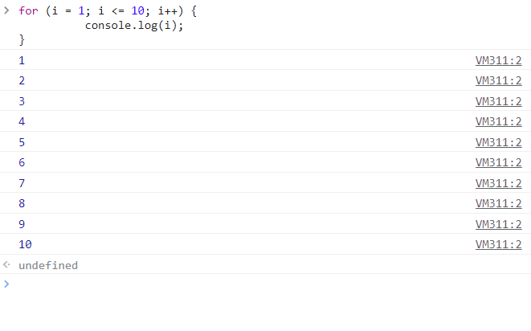

2. Program to calculate the sum of first 10 numbers

**Soln** : let sum = 0;

for ( i = 1; i <= 10; i++) {

sum += i;

}

console.log('The sum of natural numbers:', sum);

**Output** :

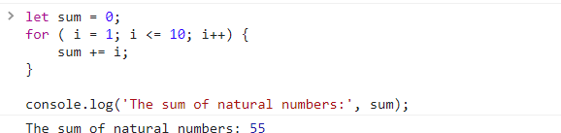

3. Make the loop stop when i is 5.

Solution: for ( i = 1; i<=5; i++) {

console.log(i);

}

Output:

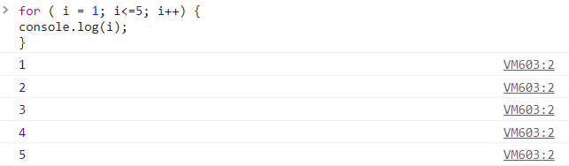

4. Write a program to print day of week name using switch case.

Solution:

let day = 3;

let dayName;

switch (day) {

case 1:

dayName = 'Sunday';

break;

case 2:

dayName = 'Monday';

break;

case 3:

dayName = 'Tuesday';

break;

case 4:

dayName = 'Wednesday';

break;

case 5:

dayName = 'Thursday';

break;

case 6:

dayName = 'Friday';

break;

case 7:

dayName = 'Saturday';

break;

default:

dayName = 'Invalid day';

}

console.log(dayName);

**Output** :

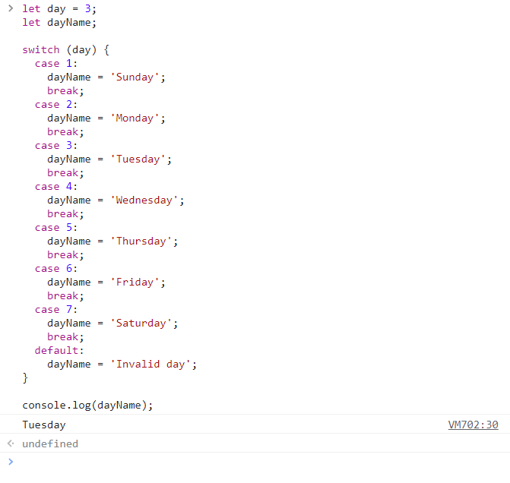

5. Write a program to print total number of days in a month using switch case.

Solution : let year = 2022;

let month = 4;

let dayCount;

switch (month) {

case 1:

case 3:

case 5:

case 7:

case 8:

case 10:

case 12:

dayCount = 31;

break;

case 4:

case 6:

case 9:

case 11:

dayCount = 30;

break;

case 2:

if ((year % 4 == 0 && !(year % 100 == 0)) || year % 400 == 0) {

dayCount = 29;

} else {

dayCount = 28;

}

break;

default:

dayCount = -1;

}

**OUTPUT** :

